Installation guide

Please follow guideline before for automation infrastructure setup & running

## Prepare environment:

* 1. Download & Install JRE – <https://www.oracle.com/java/technologies/javase-jre8-downloads.html> (Please pick the version suitable to your local system
  2. Set class path for JRE javaw
  3. Recheck: go to Control Panel > Java > Java tab > View (you should see as below)

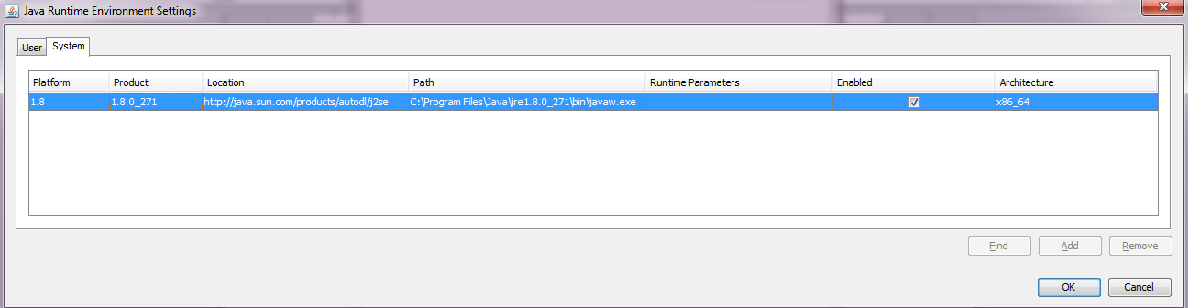

* 1. Download & Install Firefox 84.0.2 (this work with geckodriver.exe in automation package) - <https://ftp.mozilla.org/pub/firefox/releases/84.0.2/win64/en-US/Firefox%20Setup%2084.0.2.exe>
  2. Download & Install latest Google Chrome (chromedriver.exe along with automation package need to matches the version of Chrome, if not please feel free to upgrade chrome driver - Current checked as Version 87.0.4280.141 (Official Build) (64-bit))
  3. Install Python 3.8.2 (attached to Github repository)
     + Make sure class path is checked along with the installation

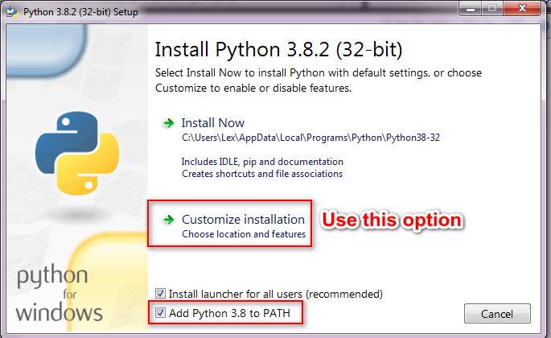

* + - Make sure PIP and Association Type option is selected for easy installation later

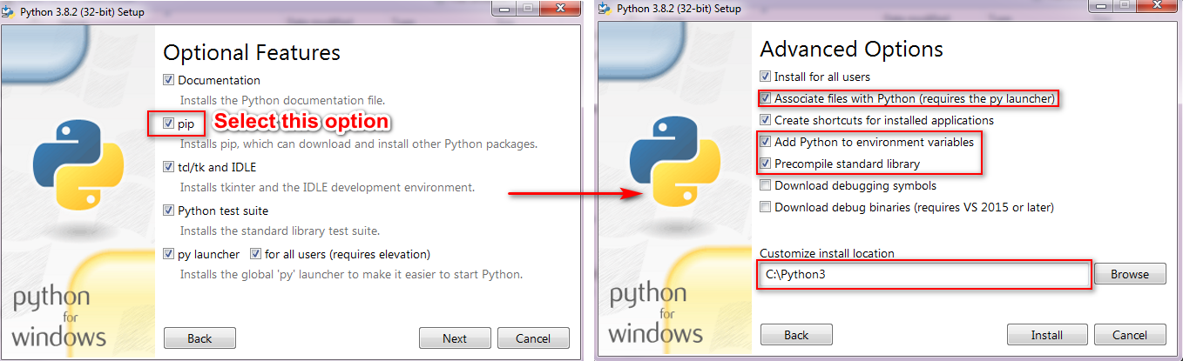

* + - Recheck version by launching cmd and type command:
* python --version
* pip list

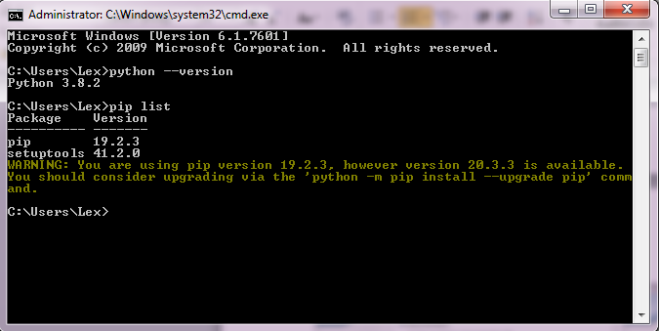

* 1. Install pip packages below from command-line above:

pip install pytest

pip install selenium

pip install requests

pip install pandas

pip install allure-pytest

pip install openpyxl==3.0.3

pip install beautifulsoup4

* 1. Recheck by command-line: pip list (you should see successfully installed packages as below)

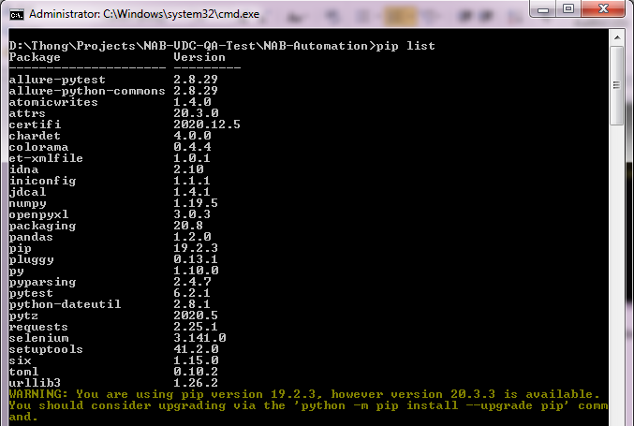

* 1. Extract the allure.zip to NAB-Automation folder as the screenshot below

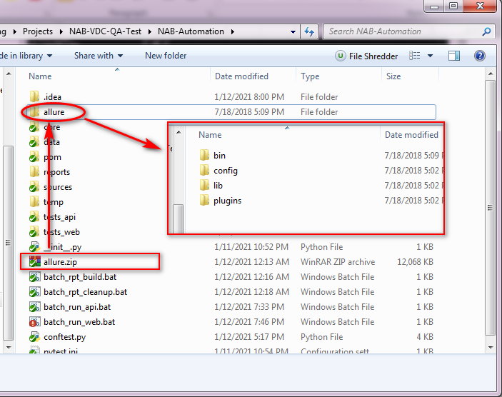

## Run test & report

* 1. Run batch to cleanup temp files & previous reports: **batch_rpt_cleanup.bat**

This batch should be run when you want to clear up all report history, this action results in losing the TREND line for tracking test run history

* 1. Run batch file for API tests: **batch_run_api.bat**

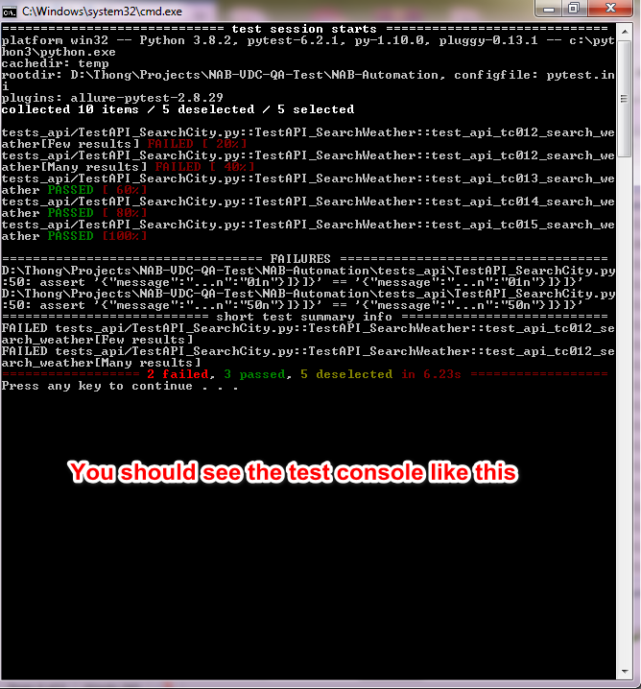

* 1. Run batch file for web GUI tests: **batch_run_web.bat**

*Note*:

* To switch the browser platform to Chrome, edit the web batch file and modify:

*--browser firefox* to *--browser chrome*

* To run in headless Chrome mode (run behind the screen without launching browser), edit the web batch file and add one more parameter to the command-line:

*--browser chrome* --*headless*

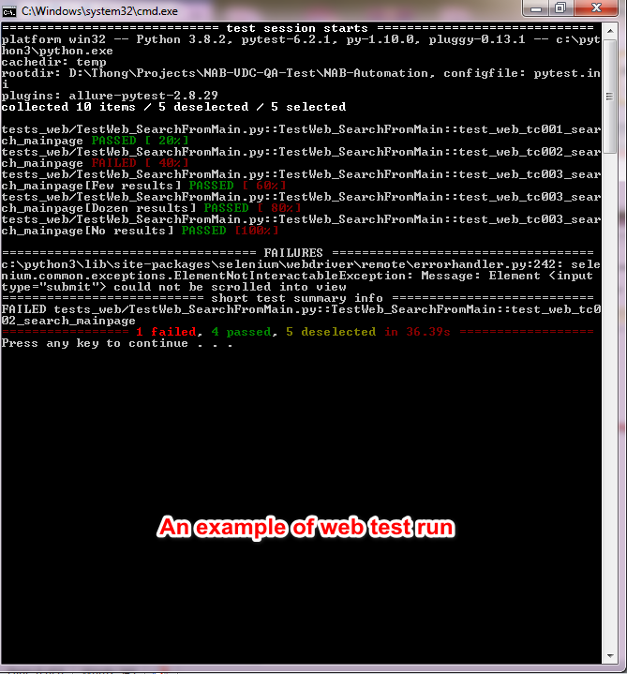

* 1. Build allure report for all test results: **batch_rpt_build.bat** (need to run api or web or both test first)

You should see a new browser instance launching for test reports like below

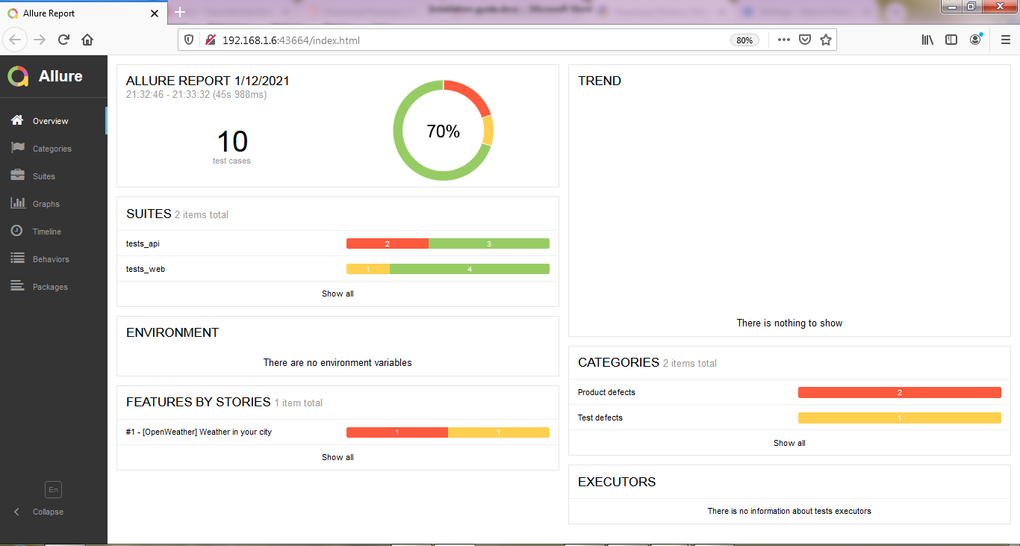

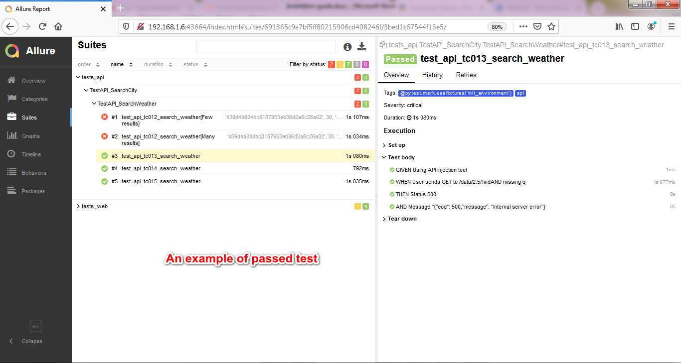

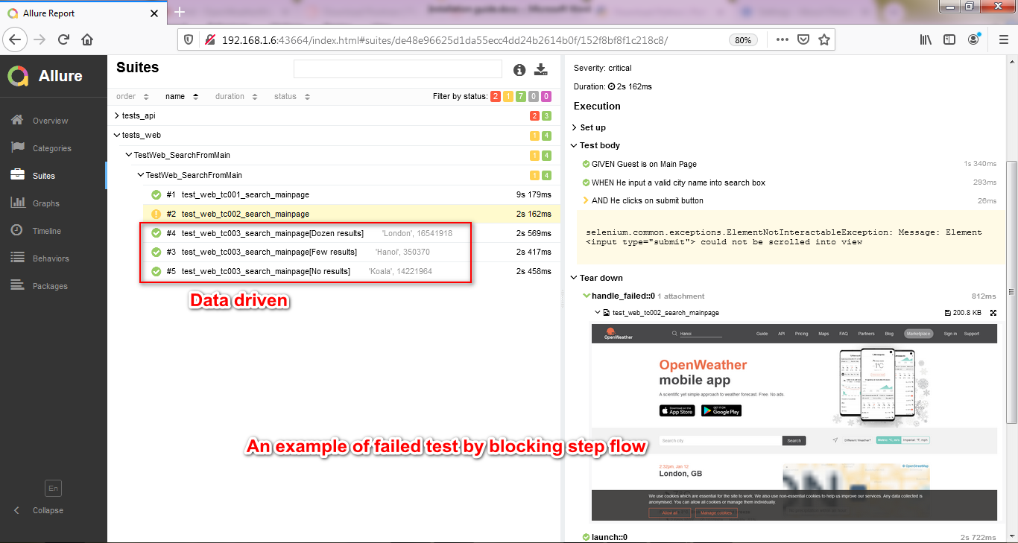

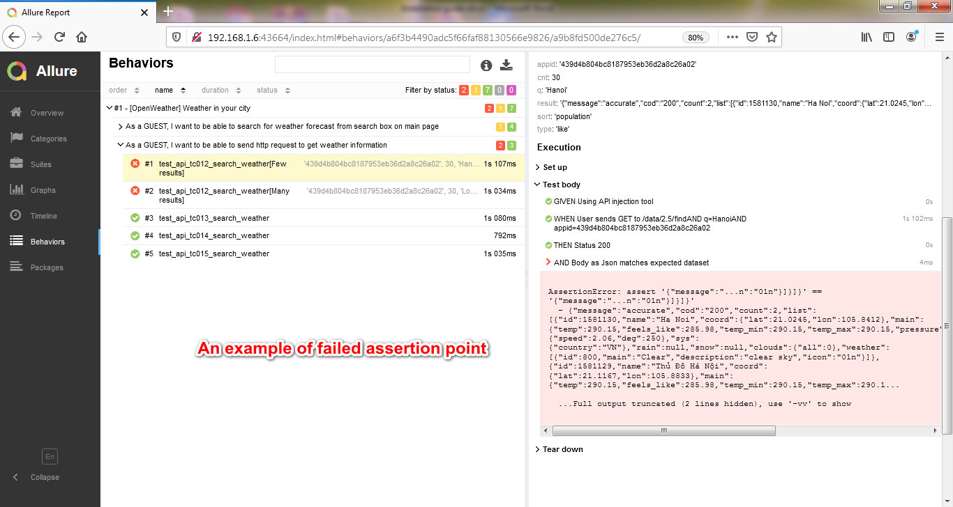

## Dev note:

* This version does not include “Distribution execution” solution using Selenium Grid, but possible to integrate into the framework
* Cloud Solution is not included
* Parallel test run is very depend on how the Jenkin integration is designed, so I leave the current parameter design as my mandatory solution (it can be better ☺)
* I skipped integrating CI/CD solution using Jenkin
* I created two methods of data driven
  + Directly dataset using in source file (Web sample)
  + Loading resource tests from excel file (API sample)
* Allure report provides a full CI/CD BDD test report infrastructure, it can be integrated into Jenkin and be published as a service report
* Automation Framework integrates the technical design below for better maintenance:
  + Separating technical abstract and library design into framework core for multi projects linking & reuse propose
  + Page factory & Data factory to maintain Page Object Model design

Thank you